**Course 1 Module 1**

**Case study**

Jamie from Adventure Works has emailed you questions about the inventory file you are working on.

She needs you to find the following numbers and submit them to her:

* The number of listings for gear components.
* The number of orders placed with Z123 in 2023.
* The number of orders placed with Z123 in 2022.
* The number of orders for mountain bike frames.
* The number of mountain bike orders with a stock level of over 500.

You will need to use the **Filter** feature to extract the information from the file required to answer these questions.

1. Number of listings for gear components: 20

Clue:



At the bottom left of the workbook will show how many records are found after filtering

1. The number of orders placed with Z123 in 2023: 0

There was no record for the year 2023

1. The number of orders placed with Z123 in 2022.  
   
2. 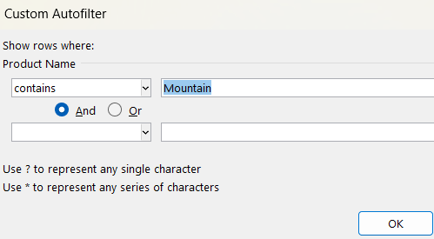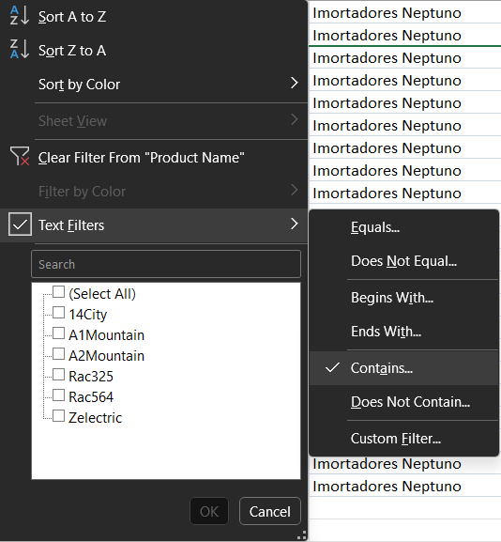The number of orders for mountain bike frames: 22
3. 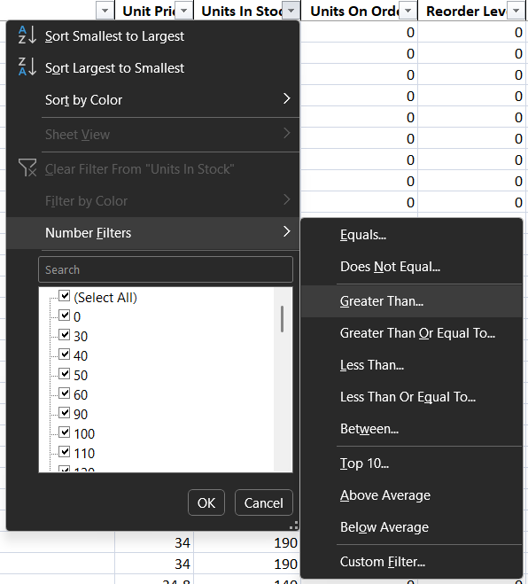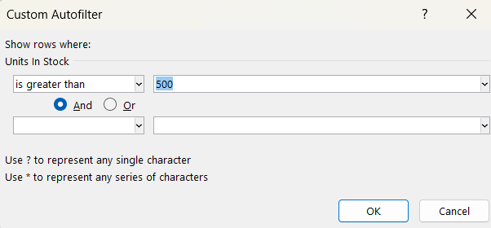The number of mountain bike orders with a stock level of over 500: 40